Use-Case Realization Report (Design)
Update Page

Issue <1.0>
Revision History
Date | Issue | Description | Author
29/11/09 | 1.0 | Initial Version | Rajendran Kumaraguru

Table of Contents
1. Brief Description 4
2. Flow of Events 4
2.1 Standard Flow 4
2.2 Exception Flow 4
3. Interaction Diagrams 5
3.1 Sequence Diagram for Update Page 5
4. Participating Objects 5
5. Class Diagrams 6
5.1 Class Diagram for Update Page 6
6. Derived Requirements 6

Use-Case Realization Report (Design)
Update Page

Brief Description
Once the company site is created then outline is created , finally portal admin will be able to perform the update operation to update the page which is already created. Any content with in the each page can be modifed.

Flow of Events

Standard Flow
- Portal Admin log into the system, and go to Page Admin Page.
- Edit outline will be invoked before proceed to update the page.
- By clicking the “btnAdd_Click” button, the Page maintenance screen will be invoked in order to modify the page and its content for the created outline and site.
- Load fields will be used to load the field values.
- Get page will be used to get the particular page before proceed to update the page.
- Validate Fields will be used to validate the field data before proceed to update the page.
- JMD Page Save will be used to save the updated content of the page.
- JMD Page MOD Save will be used to save the module for the updated page.
- Upon updating the page and module it will be shown to the portal admin for the success status.

Exception Flow
- If the page which is not available for editing then the exception should be thrown.
- If any error detected while validating the filed values the error message should be thrown to portal admin.

Interaction Diagrams

Sequence Diagram for Update Page
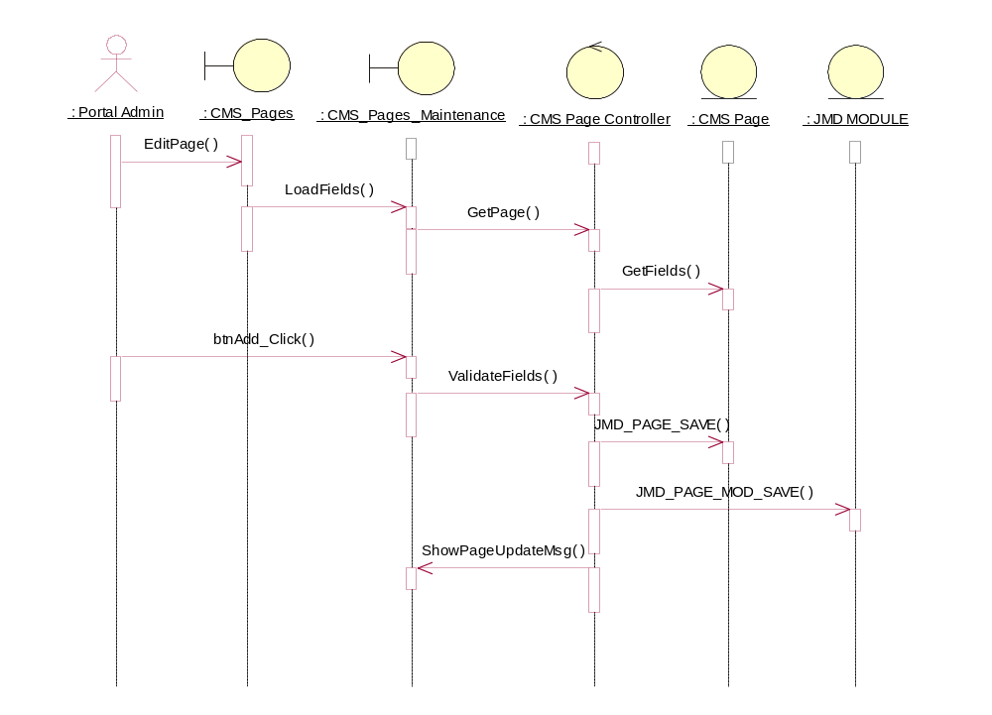

Participating Objects
: CMS Page

: CMS Page Controller

: CMS_Pages

: CMS_Pages_Maintenance

: JMD MODULE

: Portal Admin

Class Diagrams

Class Diagram for Update Page
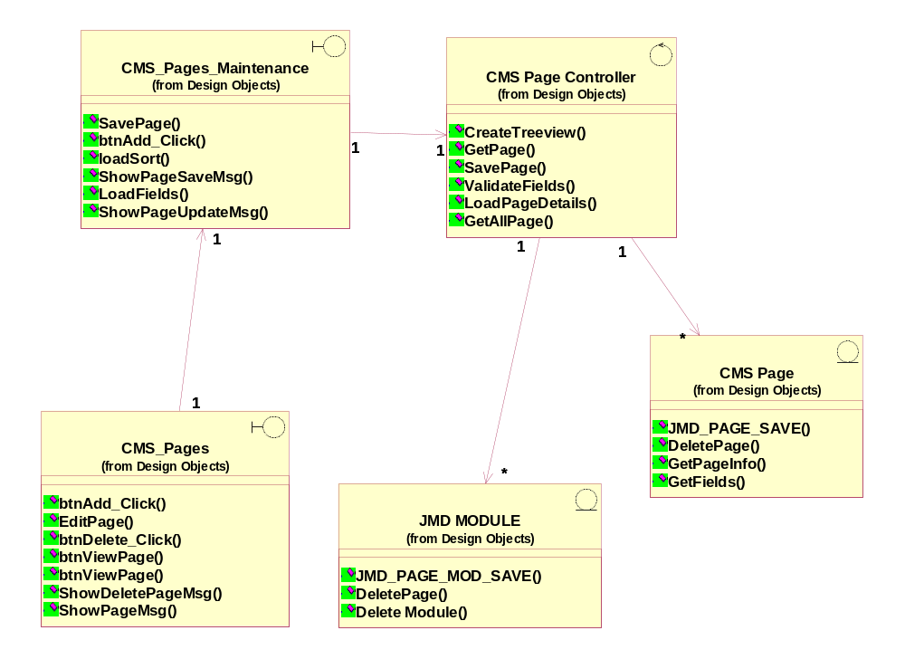

Derived Requirements
[enter the derived requirements here]

